Nama: I Kadek Yoga Dwipayana

NIM: 2401010273

Kelas: C

Prodi: Menajemen Teknik Informatika

Matkul: Jaringan dan Komunikasi data

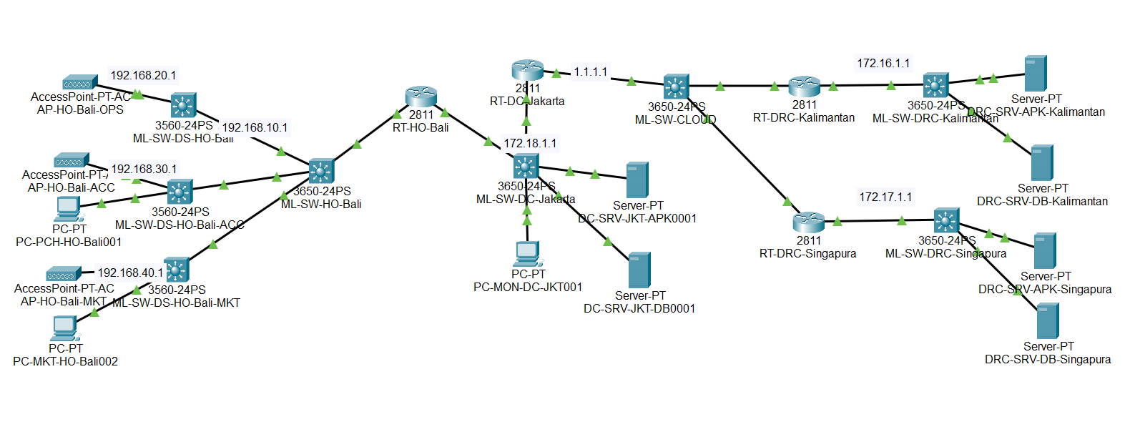

1. IP Address
2. DC dan DRC

* Router DC Jakarta : 1.1.1.1
* Router DRC Kalimantan : 1.1.1.2
* Router DRC Singapura : 1.1.1.3

1. DRC

* Router DRC Kalimantan : 172.16.1.1
* Router DRC Singapura : 172.17.1.1

1. DC dan HO

* Router DC Jakarta : 172.18.1.1
* Router HO Bali : 172.18.1.100

1. Router HO Bali

* Vlan 10 Bali : 192.168.10.1
* Vlan 20 Operasional : 192.168.20.1
* Vlan 30 Akunting : 192.168.30.1
* Vlan 40 Marketing : 192.168.40.1

1. Konfigurasi
2. Router DC Jakarta

Router>en

Router conf t

Enter configuration commands, one per line. End with CNTL/Z.

Router (config)#int fa0/0

Router (config-if)#ip add 1.1.1.1 255.0.0.0

Router (config-if)#exit

Router (config)#int fa0/1

Router (config-if)#ip add 172.18.1.1 255.255.0.0

Router (config-if)#ex

Router (config)#int fa0/1

Router (config-if)#no sh

Router (config-if)#

LINK-5-CHANGED: Interface FastEthernet0/1, changed state to up

LINEPROTO-5-UPDOWN: Line protocol on Interface FastEthernet0/1, changed state to up

Router (config-if)#int fa0/0

Router (config-if)#no sh

Router (config-if)#

LINK-5-CHANGED: Interface FastEthernet0/0, changed state to up

LINEPROTO-5-UPDOWN: Line protocol on Interface FastEthernet0/0, changed state to up

Router(config-if)#

Router(config-if)#exit

Router (config)#ip dhcp pool DC-Jakarta

Router (dhcp-config)#net 172.16.0.0 255.255.0.0

Router (dhcp-config) #def 172.16.1.1

Router (dhcp-config)#dns 172.16.1.1

Router (dhcp-config)#exit

Router (config)#

1. Router DRC Singapura

Router>en

Router#conf t

Enter configuration commands, one per line. End with CNTL/Z.

Router (config)#int fa0/0

Router(config-if)#ip add 1.1.1.1 255.0.0.0

Router(config-if)#exit

Router(config)#int fa0/1

Router (config-if)#ip add 172.16.1.1 255.255.0.0

Router (config-if)#ex

Router(config)#int fa0/1

Router (config-if)#no sh

Dragon Router (config-if)#

LINK-5-CHANGED: Interface FastEthernet0/1, changed state to up

LINEPROTO-5-UPDOWN: Line protocol on Interface FastEthernet0/1, changed state to up

Router (config-if)#int fa0/0

Router (config-if)#no sh

Router (config-if)#

LINK-5-CHANGED: Interface FastEthernet0/0, changed state to up

LINEPROTO-5-UPDOWN: Line protocol on Interface FastEthernet0/0, changed state to up

Router (config-if)#

Router (config-if)#exit

Router (config)#ip dhcp pool DRC-Singapura

Router (dhcp-config)#net 172.16.0.0 255.255.0.0

Router (dhcp-config) #def 172.16.1.1

Router (dhcp-config)#dns 172.16.1.1

Router (dhcp-config)#exit

Router(config)#rou rip

Router(config-router) #net 172.16.0.0

Router(config-router) #net 1.0.0.0

Router (config-router) #ex

Router(config)#

1. Router DRC Kalimantan

Router>en

Router#conf t

Enter configuration commands, one per line. End with CNTL/Z.

Router (config)#int fa0/0

Router(config-if)#ip add 1.1.1.3 255.0.0.0

Router(config-if)#exit

Router(config)#int fa0/1

Router (config-if)#ip add 172.17.1.1 255.255.0.0

Router (config-if)#ex

Router(config)#int fa0/1

Router (config-if)#no sh

Dragon Router (config-if)#

LINK-5-CHANGED: Interface FastEthernet0/1, changed state to up

LINEPROTO-5-UPDOWN: Line protocol on Interface FastEthernet0/1, changed state to up

Router (config-if)#int fa0/0

Router (config-if)#no sh

Router (config-if)#

LINK-5-CHANGED: Interface FastEthernet0/0, changed state to up

LINEPROTO-5-UPDOWN: Line protocol on Interface FastEthernet0/0, changed state to up

Router (config-if)#

Router (config-if)#exit

Router (config)#ip dhcp pool DRC-Singapura

Router (dhcp-config)#net 172.17.0.0 255.255.0.0

Router (dhcp-config) #def 172.17.1.1

Router (dhcp-config)#dns 172.17.1.1

Router (dhcp-config)#exit

Router(config)#rou rip

Router(config-router) #net 172.17.0.0

Router(config-router) #net 1.0.0.0

Router (config-router) #ex

Router(config)#

1. Router HO Bali

Router>en

Router#conf t

Enter configuration commands, one per line. End with CNTL/Z.

Router(config)#int fa0/1

Router (config-if)#no sh

Dragon Router (config-if)#

LINK-5-CHANGED: Interface FastEthernet0/1, changed state to up

LINEPROTO-5-UPDOWN: Line protocol on Interface FastEthernet0/1, changed state to up

Router (config-if)#int fa0/0

Router (config-if)#no sh

Router (config-if)#

LINK-5-CHANGED: Interface FastEthernet0/0, changed state to up

LINEPROTO-5-UPDOWN: Line protocol on Interface FastEthernet0/0, changed state to up

Router (config)#int fa0/1.10

Router (config-subif)#

%LINK-5-CHANGED: Interface FastEthernet0/1.10, changed state to up

%LINEPROTO-5-UPDOWN: Line protocol on Interface FastEthernet0/1.10, changed state to up

Router(config-subif) #encapsulation dot 10

Router(config-subif)#ip add 192.168.10.1 255.255.255.0

Router(config-subif)#ex

Router (config)#int fa0/1.20

Router (config-subif)#

%LINK-5-CHANGED: Interface FastEthernet0/1.20, changed state to up

%LINEPROTO-5-UPDOWN: Line protocol on Interface FastEthernet0/1.20, changed state to up

Router(config-subif) #encapsulation dot 20

Router(config-subif)#ip add 192.168.20.1 255.255.255.0

Router(config-subif)#ex

Router (config)#int fa0/1.30

Router (config-subif)#

%LINK-5-CHANGED: Interface FastEthernet0/1.30, changed state to up

%LINEPROTO-5-UPDOWN: Line protocol on Interface FastEthernet0/1.30, changed state to up

Router(config-subif) #encapsulation dot 30

Router(config-subif)#ip add 192.168.30.1 255.255.255.0

Router(config-subif)#ex

Router (config)#int fa0/1.40

Router (config-subif)#

%LINK-5-CHANGED: Interface FastEthernet0/1.40, changed state to up

%LINEPROTO-5-UPDOWN: Line protocol on Interface FastEthernet0/1.40, changed state to up

Router(config-subif) #encapsulation dot 40

Router(config-subif)#ip add 192.168.40.1 255.255.255.0

Router(config-subif)#ex

Router (config)#ip dhcp pool Bali

Router (dhcp-config)#net 192.168.10.0 255.255.255.0

Router (dhcp-config) #def 192.168.10.1

Router (dhcp-config)#dns 192.168.10.1

Router (dhcp-config)#exit

Router (config)#ip dhcp pool OPS

Router (dhcp-config)#net 192.168.20.0 255.255.255.0

Router (dhcp-config) #def 192.168.20.1

Router (dhcp-config)#dns 192.168.20.1

Router (dhcp-config)#exit

Router (config)#ip dhcp pool ACC

Router (dhcp-config)#net 192.168.30.0 255.255.255.0

Router (dhcp-config) #def 192.168.30.1

Router (dhcp-config)#dns 192.168.30.1

Router (dhcp-config)#exit

Router (config)#ip dhcp pool MKT

Router (dhcp-config)#net 192.168.40.0 255.255.255.0

Router (dhcp-config) #def 192.168.40.1

Router (dhcp-config)#dns 192.168.40.1

Router (dhcp-config)#exit

Router(config)#rou rip

Router(config-router) #net 192.168.10.0

Router(config-router) #net 192.168.20.0

Router(config-router) #net 192.168.30.0

Router(config-router) #net 192.168.40.0

Router(config-router) #net 172.18.0.0

Router (config-router) #ex

Router(config)#

1. ML-SW-HO-Bali

Would you like to enter the initial configuration dialog? [yes/no]: no

Switch>ena

Switch#conf t

Enter configuration commands, one per line. End with CNTL/Z.

Switch(config)#vl 10

Switch(config-vlan)#na

Switch(config-vlan)#name Bali

Switch(config-vlan)#vl 20

Switch(config-vlan)#na

Switch(config-vlan)#name OPS

Switch(config-vlan)#vl 30

Switch(config-vlan)#na ACC

Switch(config-vlan)#vl 40

Switch(config-vlan)#na MKT

Switch(config-vlan)#ex

Switch(config)#int gig1/0/1

Switch(config-if)#sw mo tr

Switch(config-if)#

%LINEPROTO-5-UPDOWN: Line protocol on Interface GigabitEthernet1/0/1, changed state to down

%LINEPROTO-5-UPDOWN: Line protocol on Interface GigabitEthernet1/0/1, changed state to up

Switch(config-if)#sw

Switch(config-if)#switchport tr

Switch(config-if)#switchport trunk all

Switch(config-if)#switchport trunk allowed vl

Switch(config-if)#switchport trunk allowed vlan 10,20

Switch(config-if)#ex

Switch(config)#int gig1/0/2

Switch(config-if)#sw mo acc

Switch(config-if)#switchport acc

Switch(config-if)#switchport access vlan 30

Switch(config)#int gig1/0/3

Switch(config-if)#sw mo acc

Switch(config-if)#sw acc vl 40

Switch(config-if)#ex

Switch(config)#

1. ML-SW-DS-HO-Bali

Switch>en

Switch#conf t

Enter configuration commands, one per line. End with CNTL/Z.

Switch(config)#vl 10

Switch(config-vlan)#na Bali

Switch(config-vlan)#vl 20

Switch(config-vlan)#na OPS

Switch(config-vlan)#ex

Switch(config)#int fa0/1

Switch(config-if)#sw mo acc

Switch(config-if)#sw acc vl 20

Switch(config-if)#ex

Switch(config)#int gig0/1

Switch(config-if)#sw tr enc dot

Switch(config-if)#sw mo tr

Switch(config-if)#sw tr all vl 10,20

Switch(config-if)#exit

Switch(config)#